Integrating the Healthcare Enterprise



IHE Patient Care Coordination
Technical Framework Supplement

Early Hearing Detection and Intervention-Workflow Definition
(EHDI-WD)

Draft for Public Comment

Date: June 03, 2013
Author: IHE PCC Technical Committee
Email: pcc@ihe.net
Foreword
This is a supplement to the IHE Patient Care Coordination (PCC) Technical Framework V8.0. Each supplement undergoes a process of public comment and trial implementation before being incorporated into the volumes of the Technical Frameworks.
This supplement is published on June 03, 2013 for Public Comment. Comments are invited and may be submitted at http://www.ihe.net/pcc/pcccomments.cfm. In order to be considered in development of the Trial Implementation version of the supplement, comments must be received by July 03, 2013.
This supplement describes changes to the existing technical framework documents.
“Boxed” instructions like the sample below indicate to the Volume Editor how to integrate the relevant section(s) into the relevant Technical Framework volume.
Amend section X.X by the following:
Where the amendment adds text, make the added text bold underline. Where the amendment removes text, make the removed text bold strikethrough. When entire new sections are added, introduce with editor’s instructions to “add new text” or similar, which for readability are not bolded or underlined.

General information about IHE can be found at: www.ihe.net.
Information about the IHE Patient Care Coordination domain can be found at: http://www.ihe.net/Domains/index.cfm.
Information about the organization of IHE Technical Frameworks and Supplements and the process used to create them can be found at: http://www.ihe.net/About/process.cfm and http://www.ihe.net/profiles/index.cfm.
The current version of the IHE Patient Care Coordination Technical Framework can be found at: http://www.ihe.net/Technical_Framework/index.cfm.
CONTENTS

Introduction to this Supplement 5
Open Issues and Questions 5
Closed Issues 6
General Introduction 8
Appendix A - Actor Summary Definitions 8
Appendix B - Transaction Summary Definitions 8
Glossary 8
Volume 1 – Profiles 10
Copyright Licenses 10
Domain-specific additions 10
X Early Hearing Detection and Intervention-Workflow Document (EHDI-WD) Profile 11
X.1 EHDI-WD Actors, Transactions, and Content Modules 11
X.1.1 Actor Descriptions and Actor Profile Requirements 19
X.1.1.1 Plan of Care Manager 19
X.1.1.2 Screening Requestor 20
X.1.1.3 Order Placer 20
X.1.1.4 Care Summary Generator 21
X.2 EHDI-WD Actor Options 21
X.2.1 US Realm Option 21
X.3 EHDI-WD Actor Groupings 22
X.4 EHDI-WD Overview 24
X.4.1 Concepts 24
X.4.2 Use Cases 25
X.4.2.1 Use Case #1: Newborn Hearing Screening – Simple Case 25
X.4.2.1.1 EHDI-WD Newborn Hearing Screening Workflow 26
X.4.2.1.2 EHDI-WD Process Flow 28
X.5 EHDI-WD Security Considerations 33
X.6 EHDI-WD Cross Profile Considerations 33
Appendices 35
Appendix A – Implementation Scenarios 35
A.1 Possible Actor Assignments 35
Volume 2 – Transactions 36
Volume 3 – Content Modules 37
5. Namespaces and Vocabularies 38
6 CDA Content Modules 39
6.3.1 CDA Document Content Modules 39
7 XDW Workflow Document Content Modules 40
7.1 EHDI-WD Workflow Document 40
7.2 EHDI-WD Task Content Modules 41
7.3 EHDI-WD Task Specification Overview 43
7.3.1 Task: “Create Hearing Plan of Care” 44
7.3.2 Task: “Conduct Hearing Screening” 46
7.3.3 Task: “Discharge Newborn” 47
7.3.4 Task: “Update Hearing Plan of Care” 48
7.4 Input and output documents 50
Appendices 51
Volume 3 Namespace Additions 51
Volume 4 – National Extensions 52
4 National Extensions 52
4.I National Extensions for US Realm 52
4.I.1 Comment Submission 52
4.I.2 Early Hearing Detection and Intervention – Workflow Definition (EHDI-WD) 52
4.I.2.1 National Extensions for USA 52

Introduction to this Supplement
This IHE Early Hearing Detection and Intervention-Workflow Definition (EHDI-WD) profile specifies a standard workflow to orchestrate the collection and exchange of data between clinical and program-specific public health information systems.
EHDI-WD builds upon several other IHE profiles. It utilizes actors and transactions established by the IHE ITI Cross-enterprise Document Workflow (XDW) profile. The XDW profile builds upon the document sharing mechanisms defined in the IHE ITI Cross-enterprise Document Sharing profiles (XDS.b, XDR, and XDM), as well as the transaction binding specifications for these profiles defined in IHE PCC Technical Framework Volume 2.
The use cases for the profile spans issues covered by the IHE Patient Care Coordination and IHE Quality Research and Public Health domains. Due to the complex nature of this profile, it is being developed through joint collaboration across the PCC, QRPH and ITI domains. PCC is providing technical profile documentation guidance, with backup from ITI on novel issues related to nesting of workflows. QRPH is providing subject matter expertise to guide the workflow specification.

Open Issues and Questions
# | Title | Description
12 | Task Triggering | The XDW profile does not specify how each workflow participant will be triggered to perform their tasks. One possible suggestion is to use ITI Document Metadata Subscription (DSUB) profile supplement for trial implementation (http://www.ihe.net/Technical_Framework/upload/IHE_ITI_Suppl_DSUB.pdf) to subscribe to the Workflow Document so that a workflow participant would know to read it whenever it was updated. Another option is to develop a way to use the actors from the Retrieve Process for Execution (RPE) profile (http://www.ihe.net/Technical_Framework/upload/IHE_QRPH_Suppl_RPE_Rev3-1_TI_2011-09-02.pdf) to enable the Workflow Monitor actor to act as a Process State Manager and all the other workflow participant actors to act as Process Activity Executors.  ITI is working on developing guidance around this issue. DSUB is being extended to support the needed communication between XDW participants to support the workflow.  Out of scope for 2013.
20 | Care Summary arrives before Outcome Report | In the current workflow design, if a Care Summary document arrives (baby is discharged) before the Outcome Report, then the Update Hearing Plan of Care task will fail, thus closing the workflow with a status of failed.  This situation is expected to be very unlikely, because the Outcome Report is designed to record reasons for why a screening procedure might not be performed, or might not produce a result. However, in the event that the Conduct Hearing Screening task becomes stalled for some reason, and the Care Summary arrives before the Outcome Report becomes available, then the Update Hearing Plan of Care task will fail and an exception report will be generated. Handling of this error condition is out of scope for the profile, at this time. The workflow design will be evolved to allow that when the Outcome Report becomes available, the workflow can be restarted and the documents can be reprocessed in the expected order. We are also looking at adding an event type that forces the submission of the Care Summary to wait for a reasonable period of time to avoid and minimize the potential for this processing issue to even happen.

Closed Issues

# | Title | Description
3 | Alignment of Diagnostic Study workflow and e-Referral workflow | Following the review of these two profiles at the November F2F meeting, it was hypothesized that the tasks (which seem to be very similar in nature) could be aligned into a single set of tasks which were constrained for use in each of the different profiles. This remains to be seen, and the conclusion of this investigation will be reviewed at the March F2F. Until this work is complete, the actual tasks involved in each of the underlying workflows remains an unknown.  Analysis work is on-going and an associated study has been documented to encapsulate the current thinking on this subject. Please read the associated document titled, “Task Analysis 20130307.pdf”  3/29/2013  Following the Treviso F2F, it was decided that the basic study workflow will not be treated as a variant of the basic e-referral workflow. The study workflow will have its own defined workflow which will be specified in the BeR-WD profile.  5/1/2013  Following the Oakbrook F2F review, it was decided that dependence on a subordinate workflow would be removed. Actors may use another XDW workflow or use an internally defined workflow.
7 | Creation of QRDA cat 1 | The EHDI-WD profile will include a workflow actor responsible for generating the quality measure (QM) document.  This complexity was removed from the profile in May, 2013.
8 | Workflow Monitor Actor | A workflow participant with the role of reviewing the content in the EHDI-WD workflow document may be needed to analyze the progress of the workflow. Out of scope for 2013.
1 | Minimal Care Plan and Quality Measure Workflows | The workflow steps for creating and updating care plans and the workflow steps for creating quality measure reports are integral to the context of EHDI-WD profile. However, depiction of these workflows within the 2012-2013 profile will be out of scope because the underlying workflow definitions for care plans and quality measures are under development at this time. Out of scope for 2013.
9 | Document Registry/Repository | The presence of the Document Registry/Repository is specified in the XDW framework. It is, therefore, an implied actor in this profile. It does not need to be depicted as an actor in this profile. Its presence is implied because the XDS.b functionality defined in XDW is assumed to be present in supporting this profile.  XDW defines a Workflow Management framework that works in XDS, XDM XDR (and from the next year XCA)... the type of sharing infrastructure is not a constraint.

General Introduction
Appendix A - Actor Summary Definitions
Add the following actors to the IHE Technical Frameworks General Introduction list of Actors:
No new actors are defined by this profile.
Appendix B - Transaction Summary Definitions
Add the following transactions to the IHE Technical Frameworks General Introduction list of Transactions:
No new transactions are defined by this profile.
Glossary
Add the following glossary terms to the IHE Technical Frameworks General Introduction Glossary:

Glossary Term | Definition
Study | A study, in this context, is a test ordered by a clinician to gain information which helps to diagnose a patient’s condition. A screening is a type of test which may include a very simple result interpretation, like pass or fail, normal or abnormal. In the context of this profile, the three concepts: study, test and screening can be classified a synonymous.
Results | Information measured or produced by a test. This is observable data.
Result Interpretation | A categorization of a result to map actual measures or test observations to a set of possible meanings associated with the test, for example, in a hearing screening test, a measure of lower than 20 dBHL could be interpreted as a “Pass” while a measure of higher than 20 dBHL could be interpreted as a “Fail”. Results are what they are, but interpretations could vary by device, or by jurisdiction, for example, in some cases, the cut off between normal and abnormal could be30 dBHL.
Outcome Report | An outcome report may consider multiple testing results and result interpretations into consideration. For example, if a newborn’s hearing is screened and the results for the left ear are interpreted as a “fail”, and the right ear’s result interpretation is a “pass”, then the outcome report may indicate to “Refer” the patient for further testing. If the newborn is retested, and the new result interpretation for the left ear is a “pass”, then the outcome report for the newborn would include two screening procedures and the aggregate hearing screening outcome may be a “Pass”. So the plan of care would follow normal well-baby hearing care guidelines.
Referral | In the context of this profile, a referral is a request for a treatment action to be taken. The treatment could involve performing a procedure or following some other set of instructions. A referral initiates one or more orders to be placed.
Order | In the context of this profile. An order is a request for one or more services to be performed. The services are likely a procedure to be performed, but they also could include other actions such as administering an assessment questionnaire, or making a diet change. In this profile, a referral causes an order to be placed and that order, when filled, completes the referral request.
Plan of Care | A plan of care is “specialty focused”. A patient may have multiple plans of care: one from a cardiologist, another from a hearing specialist, another from a nutritionist, etc. These plans of care are developed from the point of view of the specialty or sub-specialty. They are not necessarily reconciled to take other plans of care into consideration.
Care Plan | A patient has only one care plan. This is the patient-centered holistic view of all the various plans of care reconciled together, and adopted by the patient as what they actually agree they intend to do.

Volume 1 – Profiles

Copyright Licenses
Add the following to the IHE Technical Frameworks General Introduction Copyright section:
No additional copyright licenses apply.

Domain-specific additions
No additional domain-specific additions apply.

Add Section X

X Early Hearing Detection and Intervention-Workflow Document (EHDI-WD) Profile
This IHE EHDI-WD profile specifies a standard workflow to orchestrate the collection and exchange of newborn hearing screening information between clinical and EHDI program public health information systems.

X.1 EHDI-WD Actors, Transactions, and Content Modules
This section defines the actors, transactions, and/or content modules in this profile. General definitions of actors are given in the Technical Frameworks General Introduction Appendix A at http://www.ihe.net/Technical_Framework/index.cfm.
A workflow definition profile defines an instrument, called a “workflow document”, to manage and track a shared document-based workflow. It records the creation of tasks and maintains a historical record of tasks as they move through the associated workflow. The workflow document also maintains the references to data inputs and outputs associated with each task. Figure X.1-1 shows the actors defined in the ITI XDW profile and the relevant transactions between them (see (http://www.ihe.net/Technical_Framework/upload/IHE_ITI_Suppl_XDW.pdf).
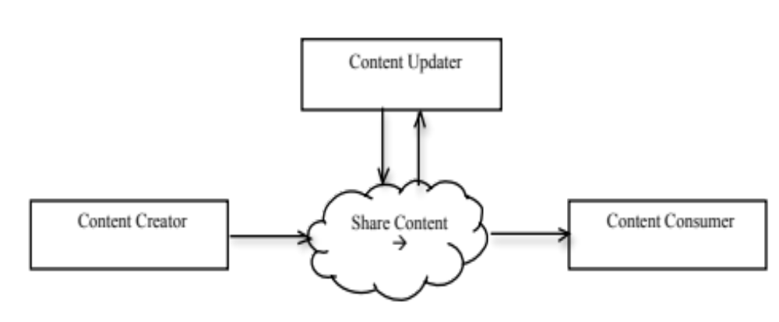
Figure X.1-1: ITI XDW Actor Transaction Diagram

A workflow definition profile also defines specific workflow participant actors which play the role of Content Creator, Content Consumer and Content Updater for the defined workflow document. A workflow participant actor gains the ability to create a workflow document, consume a workflow document, or update a workflow document through the role responsibilities assigned to it within the workflow definition profile. Table X.1-1 summarizes the EHDI-WD workflow participant actors and their roles in the context of ITI XDW profile.

Table X.1-1: EHDI-WD Workflow Participant Actors/Roles (in Context of ITI XDW Profile)
EHDI-WD actors | Actor Summary Description | ITI XDW Actor Roles | Scope for 2013 EHDI-WD
Guideline Developer | The system that provides access to jurisdictionally defined EHDI guideline which defines the requirements for newborn hearing screening and care follow-up. | TBD | Out of Scope  (Note 1)
Plan of Care Manager | The system which creates and updates the hearing plan of care.  This system is knowledgeable of the jurisdictional EHDI guidelines.  It knows how to update the hearing plan of care based on hearing screening outcomes and care summary information.  This system initiates the EHDI-WD workflow. | X.1.1.1
Screening Requester | This system is knowledgeable of the jurisdictional EHDI guidelines.  The system responsible for requesting the screening (referencing either the standing order or the screening activity identified in the Hearing Plan of Care), and optionally documenting the consent obtained to perform the screening.  The system receives one or more screening results. It is responsible for interpreting the overall screening outcome from one or more results or result interpretations. This system documents the screening outcome. | X.1.1.2
Order Placer | It is used to order the newborn hearing screening test and track that the order has been completed. The system may receive the request to perform the hearing screening from the Screening Requestor. | X.1.1.3 | This profile assumes there is a screening process in place to receive the screening request, perform the hearing screening, and return the result document.
Order Filler | The system used to schedule the newborn hearing screening test and obtain the results. This system documents the test results and returns them to the Order Placer. |  | Out of scope
Screening Device | The system used on the patient to generate and communicate the result.  In some cases, the Screening Device may communicate an interpretation of the result in addition to, or in place of, the actual measured result.  This system communicates results to the Order Filler. |  | Out of scope  (Note 2)
Care Summary Generator | The system that generates the continuity of care summary document for the newborn at the point of being discharged. | X.1.1.4
Care Plan Manager | The system which manages the holistic patient focused care plan. | TBD | Out of Scope  (Note 3)
Quality Measure Executor | The system that generates the patient-level quality measure report. | TBD  This role is envisioned to be played by the Workflow Monitor | Out of scope
Workflow Monitor | The system which monitors and processes information in the workflow documents associated with the EHDI workflow. This actor initiates or advances workflows. | TBD | Out of Scope  (Note 4)

Note 1: The Guideline Developer actor provides access to jurisdictionally defined EHDI care guidelines. Retrieval of this information could be achieved using the PCC Retrieve Clinical Knowledge (RCK) supplement for trial implementation. (http://www.ihe.net/Technical_Framework/upload/IHE_PCC_Suppl_RCK.pdf) This capability is out scope for the EHDI-WD profile in 2013. This information can be used to information EHDI-WD actors.
Note 2: The Screening Device actor is a hearing screening device. Any hearing screening device that generates a valid Hearing Screening HL7 v2 message or a CDA Hearing Screening Results Report document can be integrated into this workflow, but this aspect of the profile is not required in the scope of this version of the EHDI-WD profile. A set of HL7 Hearing Screening device messages and CDA Hearing Screening Result Report documents representing various hearing screening results is provided with this profile. These files are “givens” for the EHDI-WD profile to facilitate scope containment. These files are used to substitute for the output documents created by the Study Performer actor in the BeR workflow.
Note 3: The Care Plan Manager actor is silent actor in this profile. It is included to show the context of the EHDI-WD profile in terms of managing a hearing care plan over time. The management of the patient focused care plan is out of scope for the EHDI-WD profile in 2013.
Note 4: The Workflow Monitor actor is a silent actor in this profile. It is included to show that such an actor could participate in the EHDI workflow and could, for example, perform the role of Quality Measure Executor, in addition to providing other workflow “dash boarding” functions. The monitoring of content of the workflow document is out of scope for the EHDI-WD profile in 2013.

Figure X.1-2 shows the tasks involved in the EHDI-WD workflow.
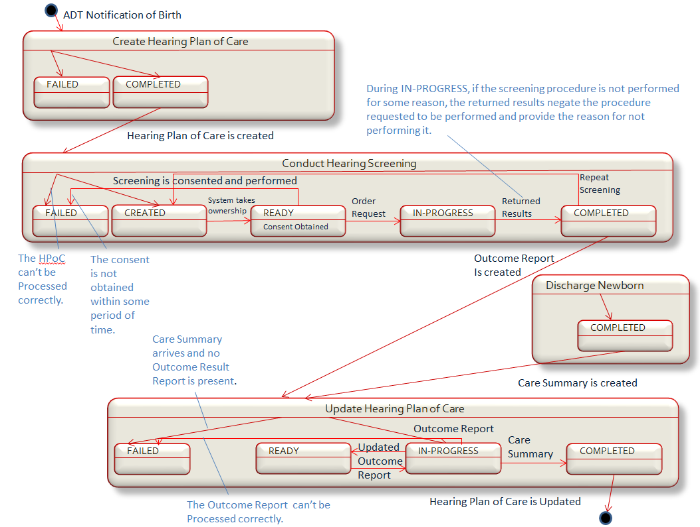
Figure X.1-2: EHDI-WD Workflow Definition

Figures X.1-3 through X.1-5 show the content of the EHDI-WD workflow document as the tasks in the workflow are initiated and completed. Each numbered panel shows a different point in time. This figure is depicted in three parts due to its extended size. The panel numbers can be cross-referenced in the sequence diagram shown in Figure. Panel number 1 shows the creation of the Workflow Document which initiates the process and then panel number 2 shows the content of the Workflow Document at the conclusion of that first task.
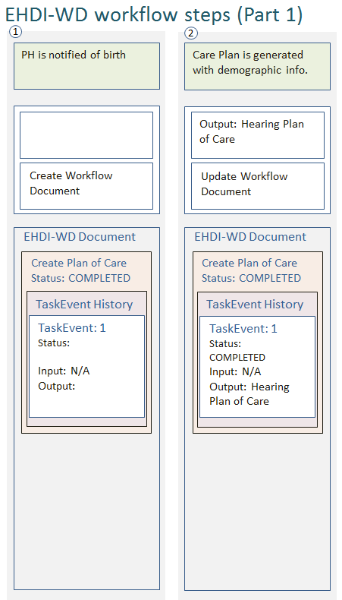

Figure X.1-3: EHDI-WD Workflow Steps (Part 1 of 3)

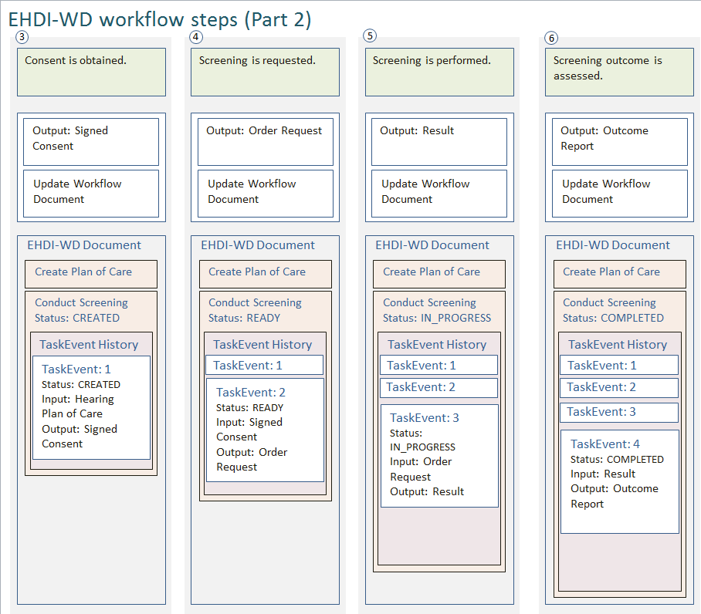
Figure X.1-4: EHDI-WD Workflow Steps (Part 2 of 3)

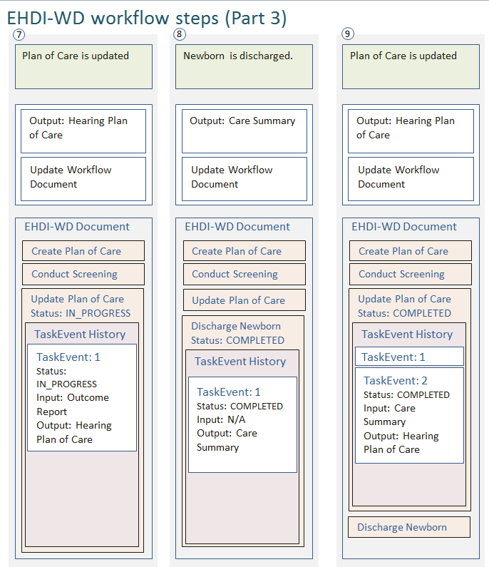
Figure X.1-5: EHDI-WD Workflow Steps (Part 3 of 3)

Table X.1-2 lists the actors performing tasks in the EHDI-WD workflow. To claim compliance with this Profile, an actor shall support all required tasks (labeled “R”) and may support the optional tasks (labeled “O”).

Table X.1-2 EHDI-WD Actors and Workflow Tasks
EHDI-WD Actors | Task Content Modules | Optionality | Reference
Plan of Care Manager | Create Hearing Care of Plan | R | EHDI-WD 7.Y.1
Plan of Care Manager | Update Hearing Care of Plan | R | EHDI-WD 7.Y.3
Care Summary Generator | Discharge Newborn | R | EHDI-WD 7.Y.4
Screening Requester | Conduct Hearing Screening | R | EHDI-WD 7.Y.2
Order Placer | Conduct Hearing Screening | R | EHDI-WD 7.Y.2

The EHDI-WD profile does not define any new transactions. EHDI-WD augments the ITI XDW profile which utilizes transactions defined in the ITI Cross-enterprise Document Sharing XDS.b profile. EHDI-WD also utilizes content document sharing mechanisms established in the PCC Technical Framework. The content bindings for the XD* transactions are defined in the IHE PCC Technical Framework Volume 2. For a brief description of the content bindings for the XD* transactions, see section X.6 EHDI-WD Cross Profile Considerations.
A workflow definition profile defines a workflow document content module. The workflow document content module is made up of content modules for the tasks required to orchestrate a specific workflow. Each workflow participant implements specific task content modules within the workflow document. Each workflow participant also consumes specific input and creates specific output content modules associated with the tasks it supports.
Input and output data specifications are defined as “document labels”. Document labels serve as a variable to represent the types of input or output documents required to support the workflow. For particular usages of the workflow, specific content documents are assigned to the document label variables. The association of a specific content document to the document label used in the workflow definition is called a “binding”. Binding of specific content documents for the EHDI workflow are defined in volume 4 of this profile. US Realm bindings have been specified initially. As a natural evolution of the profile, additional content document bindings can and will be added to meet the needs of particular jurisdictions.
Figure X.1-6 shows the task content module(s) defined in the EHDI-WD profile and the input and output document content modules which EHDI-WD actors need to consume and create. To claim support with this profile, an actor shall support all required content modules (labeled “R”) and may support optional content modules (labeled “O”).

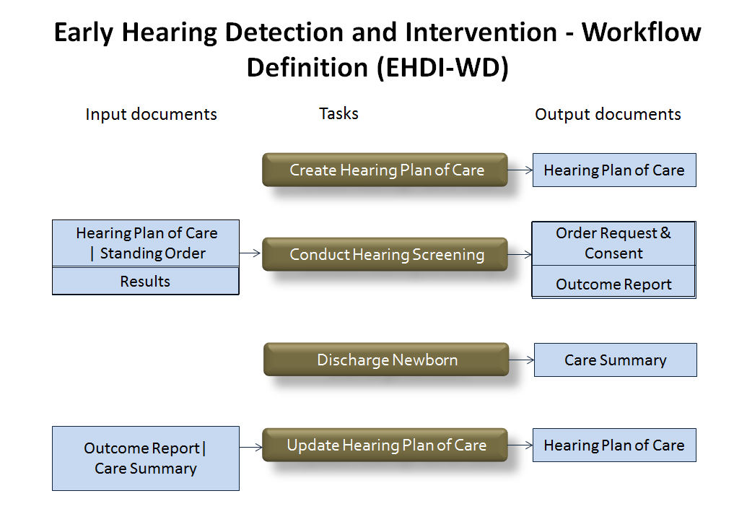
Figure X.1-6: EHDI-WD Workflow Definition Diagram
Note 1: The following symbols are used to express the logic requirements for the input documents to initiate a task: &=AND, | = OR, and X = XOR.

X.1.1 Actor Descriptions and Actor Profile Requirements

X.1.1.1 Plan of Care Manager
The actor knows about the jurisdictionally defined public health EHDI guidelines. Upon receiving a birth notification, this actor initiates an EHDI-WD workflow process for the specified patient. It creates the initial Hearing Plan of Care and records the hearing screening activities recommended for the newborn. It updates the Hearing Plan of Care when an Outcome Report becomes available, or a Care Summary becomes available. It closes the workflow once the Hearing Plan of Care has been updated with the Care Summary information generated at the time of discharge.
- This actor MAY be grouped with a NANI Subscriber actor to enable it to receive and process admission, information associated with newborns, or SHALL have access to newborn admission and ADT update information via some other means.
- It SHALL be a Content Creator, Content Consumer and Content Updater of the EHDI-WD workflow document.
- This actor SHALL be a Content Creator and Content Updater (=Content Consumer +Content Creator+know-how) of a Hearing Plan of Care document.
- This actor SHALL be a Content Consumer of an Outcome Report document.
- This actor SHALL be a Content Consumer of a Care Summary document.

X.1.1.2 Screening Requestor
This actor participates in the EHDI-WD workflow. It also knows about the jurisdictionally defined public health EHDI guidelines. Based on the recommended screening activity listed in the Hearing Plan of Care, or through the use of standing order, this actor requests the newborn hearing screening test. Prior to requesting the screening and based on jurisdictional requirements, consent for the procedure may be obtained. The request is communicated to the Order Placer actor who is responsible for returning the results generated by the screening. Based on the results, this actor is responsible for requesting any repeat testing which may be indicated, according the jurisdictional screening guidelines. This actor is responsible for assessing the screening outcome based on one or more results or result interpretations, according to jurisdictional guidelines.
- It SHALL be a Content Consumer and Content Updater of the EHDI-WD workflow document
- It SHALL be a Content Consumer for a Hearing Plan of Care document.
- It SHALL be a Content Creator for an Order Request.
- It MAY be a Content Creator for a BPPC Consent document.
- It SHALL be a Content Consumer for a Results document.
- It SHALL be a Content Creator for an Outcome Report.

X.1.1.3 Order Placer
This actor participates in the EHDI workflow. It also participates in the process used to perform the newborn hearing screening. This may utilize the IHE Basic e-Request workflow (BER-WD) or it may utilize another ordering and fulfillment process. This profile does not constrain the process used to oversee performing the screening. This actor assigns and manages the order associated with the Order Request. It shares the Results when they have been generated.
- It SHALL be a Content Consumer or Content Updater of the EHDI-WD workflow document.
- It SHOULD conform to the specification of the PCC Referral and Order Linking (ROL) Technical Supplement (http://www.ihe.net/Technical_Framework/public_comment.cfm#pcc)
- It SHALL be a Content Consumer for an Order Request document.
- It SHALL be a Content Consumer for a Results document.

X.1.1.4 Care Summary Generator
The actor participates in the EHDI workflow. It generates and shares the Care Summary for the encounter associated with the patient’s birth. The summary is generated at the point newborn is discharged or transferred.
- It SHALL be a Content Consumer or Content Updater of the EHDI-WD workflow document.
- This actor SHALL be a Content Creator of a Care Summary document.
- The Care Summary Generator actor SHALL have the ability to generate the Care Summary document when the patient in the workflow is discharged. This MAY be accomplished by having the system implementing the Care Summary Generator actor also implement the QRPH NANI Subscriber actor, or the system MAY have this capability to know when to generate the Care Summary through some other means.

X.2 EHDI-WD Actor Options

Table X.2-1: EHDI-WD - Actors and Options
Actor | Option Name | Reference
Plan of Care Initiator | US Realm | EHDI-WD X.2.1
Screening Requestor | US Realm | EHDI-WD X.2.1
Order Placer | US Realm | EHDI-WD X.2.1
Care Summary Generator | US Realm | EHDI-WD X.2.1

X.2.1 US Realm Option
Actor options permit additional constraints to be placed on profile actors. Options for a workflow participant actor enable jurisdictionally required input and output files to be specified and “attached” to the general document label used when defining a task content module.
See volume 4 for a listing of the content document bindings for each workflow participant actor implementing a US Realm option.

X.3 EHDI-WD Actor Groupings
Actor grouping in a workflow definition profile is complex. First, each workflow participant must be grouped with actors from the ITI XDW profile. These groupings specify each workflow participant’s capabilities for interacting with the workflow document content module.
Figure X.3-1 presents an overview for the grouping patterns established by the XDW profile:
- The Workflow Participant actors in this profile SHALL be grouped with actors from the XDW Profile.
The Workflow Participant actors SHOULD be grouped with one or more actors from Document Content Profiles, based on the actor’s requirements to consume input and generate output documents. In volume 1, this profile uses generic “Document Labels” to specify the input and output documents associated with a task. The binding of actual content documents is made in volume 4, on a realm by realm basis. Grouping of a Workflow Participant actor with specific Content Creator or Content Consumer actors must therefore first consider the actor options selected. As specified in XDW, the Workflow Participants in a workflow definition profile shall be grouped with actors from content document profiles as decided by the deployment environment, with the suitable Integration Profile supporting a document transport service such as XDS for Document Sharing, XDR/XDM for point-to-point directed transport, or other functionally equivalent profiles.

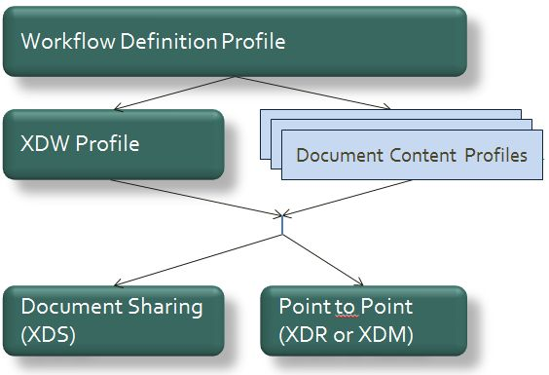
Figure X.3-1: ITI XDW Actor Groupings Diagram
The table X.3-1specifies the required groupings of EHDI-WD workflow participant actors with actors defined in the base IHE ITI XDW profile.

Table X.3-1: EHDI workflow participant actor groupings with ITI XDW actors
EHDI-WD Actor | EHDI Workflow Document
Plan of Care Manager | Content Creator  Content Updater  Content Consumer
Screening Requestor | Content Updater  Content Consumer
Order Placer | Content Updater  Content Consumer
Care Summary Generator | Content Updater  Content Consumer

Table X.3-2 summaries the generalized content document creation and consumption requirements established for EHDI-WD workflow participant actors. Specifications for the grouping of EHDI-WD actors implementing the US Realm option are defined in volume 4.

Table X.3-2: EHDI actor groupings with content document profile actors
EHDI  Workflow participant | Consent  (Optional) | Order Request | Results | Outcome  Report | Care Summary | Hearing  Plan Of Care | Patient Care Plan  (out of scope)
Plan of Care Manager |  |  |  | Content Consumer | Content Consumer | Content Creator  Content Consumer
Screening Requestor | Content Creator  Content Consumer | Content Creator | Content Consumer | Content Creator |  | Content Consumer
Order Placer |  | Content Consumer | Content Consumer
Care Summary Generator |  |  |  |  | Content Creator
Care Plan Manager  (Out of Scope 2013) |  |  |  |  |  | Content  Consumer  (Out of Scope 2013) | Content  Creator  (Out of Scope 2013)
Note 1: Input and Output document specifications are defined as “document labels”. Document labels serve as a logical placeholder for types of input or output documents required to support the workflow. For particular usages of the workflow, specific content documents are assigned to the document labels. The association of a specific content document to the document label used in the workflow definition is called a “binding”.
Table X.3-3: Content Documents Associated with Document Labels
Document Label | Content Document Description
Consent | This document contains information indicating that the hearing screening procedure received consent to be performed.
Order Request | This CDA Document records the intended procedure to be performed and indicates the consent was received.
Results | This CDA document records a screening procedure performed and the results observed. If the procedure was performed, but the results could not be collected, then the reason that results could not be obtained is recorded.
Outcome Report | This CDA document records all screening procedures performed and the results obtained. Based on the set of results observed, an outcome interpretation is assigned for each ear. If the procedure was not consented, or was not requested for medical reasons, this information is recorded.
Care Summary | This CDA document summarizes the birthing episode of care for a newborn. It is produced when the baby is discharged from the birth facility.
Hearing Plan Of Care | This CDA document, when initially created, records demographic information identifying a newborn. Later, it is updated with the hearing screening procedures, results, and result outcome assessed during the birthing episode of care. Finally, it is updated with information about active problems, and relevant risk factors for hearing-loss.

Binding of specific US Realm content documents for the EHDI workflow are defined in volume 4 of this profile.

X.4 EHDI-WD Overview
This IHE Early Hearing Detection and Intervention-Workflow Definition profile specifies a standard workflow to orchestrate the collection and exchange of data between clinical and program-specific public health information systems.
It covers the period of time from birth to the point where the newborn is discharged from the birthing facility. During EHDI-WD process, a hearing plan of care is generated for the newborn and updated with screening results as well as other information gathered from and based on the Care Summary generated at discharge. The hearing plan of care is available for the infant’s primary care provider to receive or access.
The purpose of the EHDI-WD profile is to improve the way newborn hearing screening information is tracked and shared between clinical care and public health. Automation of the Hearing Plan of Care is intended to improve health outcomes for children at risk for hearing loss.

X.4.1 Concepts
Readers need to understand the difference between results, result interpretations and screening outcomes. This is not well understood and clarification is likely needed. Test results are the actual readings or measures that result from performing a test.
Result interpretations are the translation of the test results into the more common summary of what the specific result means. For example, in hearing screening, a test result of 20 dBnHL or lower from an otoacousitc emissions screening device may be interpreted as “pass” in one country, where another country may require a result of 30 dBnHL or lower for the result interpretation to be “pass” and higher than 30 dBnHL would be interpreted as a “fail”. Some screening devices also have the ability to produce an “equipment failure” interpretation when results are outside an expected range. A hearing screening device may provide the actual test result (the dBnHL reading) or it may provide a result interpretation, or both.
A hearing screening outcome report summarizes the screening results or result interpretations for one or more tests. The outcome report assigns a screening outcome for each ear, taking into consideration all the hearing screening procedures performed during the period of time covered by the outcome report. The outcome report aggregates multiple result interpretations to produce a single outcome for the screening of each ear.

X.4.2 Use Cases

X.4.2.1 Use Case #1: Newborn Hearing Screening – Simple Case
This use case addresses the workflow and data flow supporting newborn hearing screening and hearing plan of care guidance. It does not address cases where the baby was not born at the facility (home birth, for example). It does not address the case where the baby is transferred to another facility. Both of these complexities may be able to be addressed by this workflow, but that still needs to be assessed.
Baby Joe Smith is born at a hospital and his demographic information is entered into the hospital’s EHR system as an admission.
The hospital’s EHR provides notification to the jurisdictional EHDI program information system to notify them of the birth so that the EHDI program can begin tracking the child’s hearing plan of care. (Birth Notification)
Jurisdictional EHDI care guidelines establish the standing order for all newborns to receive hearing screening. The EHDI information system includes the newborn screening as an intended treatment when the hearing plan of care is established (Create Hearing Plan of Care-COMPLETED).
At birth, a clinician performs a physical examination of the baby and records that information in the EHR. The data gathered during the physical is documented in the newborn delivery information included in the mother’s labor and delivery summary. The information gathered during the encounter is summarized in the Care Summary when the baby is discharged.
A standing order established for the jurisdiction, or the recorded recommendation to perform hearing screening in the baby’s plan of care, informs a clinician to request the screening. The clinician may obtain consent for the procedure before making the request (Conduct Hearing Screening – READY), then initiate the request to perform the hearing screening.
After the request initiates the hearing screening to be ordered (Conduct Hearing Screening – IN_PROGRESS), the screening is scheduled and a clinician performs the test with a screening device that measures either otoacoustic emissions or auditory brainstem response. The hearing screening device measures the “decibels hearing level” (dBHL) which is interpreted as either a pass or a fail for the test. The result interpretations for the screening of the newborn’s left and right ears are communicated to an information system where a document is produced to report the screening result. The screening result is returned to the system which ordered the screening, to completion of the order can be tracked, Then, the screening result is returned to the requestor, so the results can be assessed (Conduct Hearing Screening – COMPLETED).
The screening results are assessed, and the screening outcome is determined, based on jurisdictional guidelines. If guidelines suggest the need for additional screening and time permits, then additional testing may be requested (Conduct Hearing Screening-IN_PROGRESS).
When the Outcome Report is completed, it is used to update the child’s hearing plan of care. (Update Hearing Plan of Care – IN_PROGRESS).
At the point of discharge, the hospital’s EHR produces a Care Summary with additional information about the baby. The care summary includes demographic information which may not have been known at the time of birth, like the baby’s first name. It also includes other clinical information (Discharge Newborn). The information in the Care Summary is used to update the hearing plan of care. (Update Hearing Plan of Care – COMPLETED).
The hearing plan of care produced by the EHDI workflow is available to the infant’s primary care provider to provide guidance on hearing care based on best practices established by the jurisdictional guidelines. Information gathered during the EDHI workflow is available to track performance against the care goals to screen newborns’ hearing prior to discharging them from their birthing facility. Systems which have access to newborn birth admission information, newborn hearing screening results and Care Summaries can generate patient-level quality measure reports for the EHDI-1a measure designed to track a birthing facility’s performance in providing hearing screening to newborns at their facility.

X.4.2.1.1 EHDI-WD Newborn Hearing Screening Workflow
The use case addresses the workflow and data flow supporting the newborn hearing screening and short-term care plan guidance. This workflow encompasses the following aspects of newborn hearing screening:
- Creation of the hearing plan of care to record recommended hearing care activities, beginning at birth
- Newborn screening at the birthing facility, using devices with currently approved physiologic measures of auditory functions to produce screening results
- Computation of the hearing screening outcomes
- Updating of the hearing plan of care based upon screening outcomes and other information available in the discharge care summary for the newborn
- Provision of care recommendations to pediatricians to guide hearing care and follow-up
This workflow encompasses the following steps:

Workflow Step | Document Types
Workflow Step | Input Documents | Output Documents
Child is delivered |  | Admission Summary
Public health is notified of the birth | Jurisdictional EHDI guidelines  Admission Notification (demographics) | Hearing Plan of Care(demographics and Care Plan section where intent to screen newborn is recorded based on jurisdictional EHDI guidelines)
Clinician conducts initial physical exam and information about the new born is gathered in the EMR during the encounter
Newborn is due for hearing test. Consent for the test is obtained | Hearing Plan of Care | Hearing Screening Consent
After obtaining the consent, the screening test is requested | Hearing Screening Consent | Order Request
Clinician conducts hearing test using hearing screening device. Hearing screening device communicates the results back through the system used to manage orders | Order Request | Results
Results are received and interpreted/assessed | Results | Outcome Report
Screening outcomes are received by public health and used to update the Hearing Plan of Care | Outcome Report | Updated Hearing Plan of Care
Newborn is discharged and a Care Summary is shared with the Hearing Plan of Care Manager to update the Hearing Plan of Care. | Care Summary | Updated Hearing Plan of Care

X.4.2.1.2 EHDI-WD Process Flow

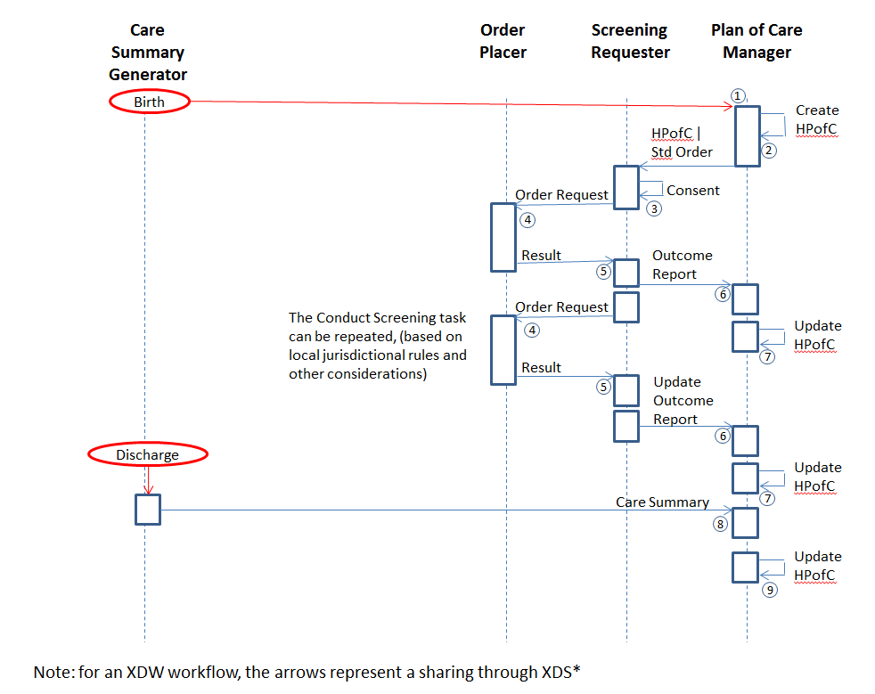
Figure X.4.2.1.2-1: Overall Workflow Document Processing
Note: Discussion above includes involvement of sharing the LDS (Newborn Delivery Information) to gather Risk Indicators. We need to decide if this is too ambitious for the 2013 development or not. If we decide to include it, then this picture and the rest of the document needs to be updated to include the sharing of the Labor and Delivery Summary.
Pre-conditions:
The workflow assumes input of a NANI message to the system playing the role of the Plan of Care Manager to trigger the creation of the EHDI Workflow Document and create the Hearing Plan of Care. It assumes the Plan of Care Manager has knowledge of the jurisdictional EHDI Guidelines. It also assumes the system playing the role of the Quality Measure Executor has input of the NANI message, or some other means of knowing the newborn admission information directly, so that this system has the means to identify the population of newborns. The workflow also assumes the system playing the role of Care Summary Generator has a means to be triggered by the discharge of the patient in the workflow, so as to generate the Care Summary at the point of discharge.
Main Flow:
- ADT Information Source or Newborn Admission Notification Manager (played by EHR or other system) sends a birth notification to the Plan of Care Manager (played by the State EHDI Program’s Information System).
- Notification of the birth event triggers the Plan of Care Manager to create the EHDI Workflow Document and create the Hearing Care Plan for the newborn. The Hearing Care Plan would indicate the intention to perform a hearing screening after birth and within the time stated in the jurisdictionally defined EHDI guidelines.
- The system playing the Screening Requestor would be triggered by the information in the Hearing Plan of Care to collect the needed Consent and the Order Request to request the Order Placer to initiate the hearing screening to be performed.
- The Order Placer/Order Filler process would perform the hearing screening and return the Results.
- The Results document with the updated order information would trigger the Order Placer to complete the order and return the Results document with updated order status information to the Screening Requester.
- The availability of a Results document would cause the Screening Requester to assess the new results and based on jurisdictional guidelines, request to order another screening, or create/update the Outcome Report document.
- The availability of a new Outcome Report would cause the Plan of Care Manager to update the Hearing Plan of Care.
- Notification of the discharge event triggers the Care Summary Generator to create the Care Summary document.
- Availability of the Care Summary document causes the Plan of Care Manager to update the Hearing Plan of Care document.
- The fully updated Hearing Plan of Care document is available to share with the PCP.
Post-conditions (simple case workflow):
At the completion of the simple case workflow in the above use case:
- A Hearing Plan of Care document has been created for the child identified in a received birth notification.
- The Screening Consent document has been collected.
- The performing of the screening procedure(s) and any associated screening results have been collected and the outcome of the screening has been summarized in the Outcome Report document. The rules for interpreting one or more screening results to determine the outcome for each ear, and for interpreting the outcome for each ear to determine the outcome at the patient level, are determined by the local jurisdiction.
For example:
Example # | Scr # | L-Ear Result | R-Ear Result | L-Ear Outcome | R-Ear Outcome | Patient-level Screening Outcome | Explanation of the example.
1 | 1 | Pass | Pass | Pass | Pass | Pass | Both ears case.
2 | 1 | Fail | Fail | Refer | Refer | Refer | The rule for determining the ear outcome may be to assign an outcome of Refer if either ear screen result is a Fail.
3 | 1 | Pass | Fail | Pass | Pass | Pass | For an ear screened more than once in a session, the ear outcome is determined by the final result reported.
3 | 1 |  | Pass
4 | 1 | Pass | Fail | Pass | Fail | Refer | For an ear screened more than one time in a session, multiple times, the ear outcome is determined by the final result reported.
4 | 1 |  | Fail
5 | 1 | DNT | DNT | Not performed,  Medical Exclusion – not indicated. | Not performed,  Medical Exclusion – not indicated. | Not performed,  Medical Exclusion – not indicated. | Screening is medically not indicated because baby is medically fragile.
6 | 1 | Pass | CNT | Pass | Not Performed | Refer (to diagnosis) | This could be a case of a child with unilateral atresia.
7 | 1 | CNT | CNT | Not Performed | Not Performed | Refer (to diagnosis) | This could be a case of a child with bilateral atresia.
8 | 1 | DNT | DNT | Parent Refusal | Parent Refusal | Parent Refusal | Parent preference.
9 | 1 | Pass | DNT | Pass | Parent Refusal | Refused | Parent preference.
10 | 1 | Fail | DNT | Fail | Parent Refusal | Refused | Parent preference.
11 | 1 | Pass | No Result: Equipment Failure | Pass | Attempted but unsuccessful – technical fail | Refer | Some screening devices produce results other than Pass or Fail, to indicate certain error conditions for the equipment.  The rule for the possible outcome values can be adjusted to match local policy.
12 | 1 | No Result: Equipment Failure | No Result: Equipment Failure | Attempted but unsuccessful – technical fail | Attempted but unsuccessful – technical fail | Refer | Some screening devices produce results other than Pass or Fail, to indicate certain error conditions for the equipment.  The rule for the possible outcome values can be adjusted to match local policy.
[Key: DNT means Did Not Test (Screen); CNT means Could Not Test (Screen)]
- The information from the Outcome Report and information from the Discharge Summary has been recorded in the Hearing Plan of Care document along with the recommended future care activities for the child.
- The data needed to generate the QRDA patient-level report has been collected.

Post-conditions (alternate case workflows):
This use case has several alternate workflows:
- The baby is transferred from the birthing hospital or discharged before hearing screening has been completed.
At the completion of the workflow in this case:
- A Hearing Plan of Care document has been created for the child identified in a received birth notification.
- The Screening Consent document may or may not been collected.
- No Outcome Report document has been created.
- The Discharge (or Transfer) Summary has been recorded in the Hearing Plan of Care document along with the recommended care plan activities for the child. Because there is no hearing screening Outcome Report, the Plan of Care indicates that the newborn screening procedure is still intended to be performed.
- The data needed to generate the QRDA patient-level report has been collected. When a Hearing Plan of Care document exists, and no Outcome Report document exists, this represents the case where the child was not screened before discharge/transfer.
- Parental consent prevents screening from being performed on both ears, or a medical reason prevents screening from being performed on both ears.
At the completion of the workflow in this case:
- A Hearing Plan of Care document has been created for the child identified in a received birth notification.
- The Screening Consent document has been collected.
- The fact that the screening procedure was not performed is recorded along with the reason. There are no associated screening results and the outcome of the screening has been summarized in the Outcome Report document.
- The information from the Outcome Report and information from the Discharge Summary has been recorded in the Hearing Plan of Care document along with the recommended care plan activities for the child.
- The data needed to generate the QRDA patient-level report has been collected. Information in the Outcome Report can be used to collect information needed for the EHDI-1a measure.

- Parental consent prevents screening from being performed on one ear, or a medical reason prevents screening from being performed on one ear, but the other ear has consent and can be screened.

At the completion of the workflow in this case:
- A Hearing Plan of Care document has been created for the child identified in a received birth notification.
- The Screening Consent document has been collected.
- The fact that the screening procedure was not performed on one of the ears is recorded along with the reason. The results associated with the ear that was screened have been collected, and the outcome of the screening has been summarized in the Outcome Report document.
- The information from the Outcome Report and information from the Discharge Summary has been recorded in the Hearing Plan of Care document along with the recommended care plan activities for the child.
- The data needed to generate the QRDA patient-level report has been collected. Information in the Outcome Report can be used to collect information needed for the EHDI-1a measure.

X.5 EHDI-WD Security Considerations
The security considerations for a content module are dependent upon the security provisions defined by the grouped actor(s). For this section please refer to the section ITI TF-1: 30.5.

X.6 EHDI-WD Cross Profile Considerations
The EHDI-WD profile is built upon several existing components defined with the IHE Technical Framework. It uses the ITI Cross-enterprise Document Workflow (XDW) as its foundation. The XDW profile makes use of the family of Cross-enterprise Document Sharing Profiles (XDS.b, XDR, and XDM), as a group called XD*. XDW also utilizes the content binding between Content Documents and the transactions used in the XD* profiles, which are defined in the IHE PCC Technical Framework, volume 2. Further,
The following excerpts from various IHE Technical Frameworks and Supplements are included below to provide non-technical readers of this profile with a basic understanding of the profiles which are its underpinnings.
About ITI Cross-enterprise Document Workflow (XDW)
The Cross-Enterprise Document Workflow (XDW) profile enables participants in a multi-organizational environment to manage and track the tasks related to patient-centric workflows as the systems hosting workflow management applications coordinate their activities for the health professionals and patients they support. XDW provides a common interoperability infrastructure upon which a wide range of specific workflow definitions may be supported. It is designed to support the complexity of health services delivery with flexibility to adapt as workflows evolve.
This profile defines an instrument, called a “Workflow Document”, to manage and track a shared workflow. It records the creation of tasks and maintains a historical record of tasks as they move through the associated workflow. The Workflow Document also maintains the references to health information input and output associated with each task. Such shared workflow status information allows the various participating systems to coordinate by:
- being aware of the history of a workflow for a patient;
- obtaining and reading the workflow’s incomplete tasks;
- updating this shared document as the workflow tasks are performed according to a referenced workflow definition.

About IHE PCC XD* Transaction Bindings
The PCC XD* transaction bindings describe how the content document payload used in a transaction of an IHE profile is related to and/or constrains the message data elements sent or received in those transactions. Transaction bindings specify the dependencies between the content and transactions used.
Chapter 4 of the IHE PCC Technical Framework, volume 2 describes how the information in a CDA Medical Document can be used to populate required and optional message data elements identified for the XD* transactions for a XDSDocumentEntry, XDSSubmissionSet, and XDSFolder.

Appendices
Appendix A – Implementation Scenarios
This appendix describes some potential scenarios for different types of systems to play the roles identified in the EHDI-WD profile. This list does not reflect the complete set of possibilities, but serves as a suggestion based on currently implemented HIT systems.
  - Possible Actor Assignments
Actor | Systems which could play this role
Hearing Plan of Care Manager | This actor could be played by a Jurisdictional Public Health System with EHDI program management capabilities as a core function. It could also be played by a specialized EHDI-IS system designed to interface with or support a jurisdictional Public Health System.
Care Summary Generator | This actor could be played by the EHR at the birthing facility or it could be played by a departmental Labor and Delivery information system.
Screening Requester | This actor could be played by a Jurisdictional Public Health System with EHDI program management capabilities as a core function. It could also be played by a specialized EHDI-IS system designed to interface with or support a jurisdictional Public Health System.
Order Placer | This actor could be played by the EHR at the birthing facility or it could be played by a departmental Labor and Delivery information system.

Volume 2 – Transactions
This profile has no Transactions.

Volume 3 – Content Modules

5. Namespaces and Vocabularies
Add to section 5 Namespaces and Vocabularies

codeSystem | codeSystemName | Description
2.16.840.1.113883.6.1 | LOINC | Logical Observation Identifier Names and Codes ; and Document Ontology
2.16.840.1.113883.6.96 | SNOMED-CT | SNOMED Controlled Terminology

Add to section 5.1.1 IHE Format Codes

Profile | Format Code | Media Type | Template ID
Early Hearing Detection and Intervention – Workflow Document (EHDI-WD) | urn:ihe:pcc:ehdiwd:2013 | Text/xml | 1.3.6.1.4.1.19376.1.5.3.1.5.4

Add to section 5.1.2 IHE ActCode Vocabulary
None

Add to section 5.1.3 IHE RoleCode Vocabulary
None

6 CDA Content Modules
None

6.3.1 CDA Document Content Modules
This profile has no CDA content modules.

7 XDW Workflow Document Content Modules

7.1 EHDI-WD Workflow Document
This workflow definition profile is assigned a specific OID that shall be used to assign an identifier to the workflowDefinitionReference element of a Workflow Document that tracks an EHDI-WD process.

type of Workflow | Workflow Definition Reference
EHDI workflow | 1.3.6.1.4.1.19376.1.5.3.1.5.4
The EHDI-WD Workflow Definition does not introduce new metadata and all the metadata elements used are the common XDS document metadata specified in ITI TF-3:4.1.5 and in ITI TF-3:5.4.6. In this section only the use of some specific metadata for the use of XDW in the EHDI-WD context is specified.

XDS Metadata Attribute | Definition
typeCode | For the Workflow Document that tracks the EHDI-WD process the code for the typeCode shall be:  A specific code for the EHDI Workflow Document will be assigned by LOINC
classCode | For the Workflow Document which tracks the EHDI-WD process the code for the classCode is defined by the XDW profile. This code is generic for any type of Workflow Document.  See XDW Supplement Section 5.4.6.1.
eventCodeList | Rule 1:  An EHDI-WD workflow shall be created with code OPEN and shall remain in this status until it is set to CLOSED.  Rule 2:  An EHDI-WD workflow should be set to CLOSED when:  - one of the tasks has the status FAILED (except for the Conduct Hearing Screening task ); or  - when you complete the workflow with the Update Hearing Plan of Care task in status COMPLETED.  See ITI TF-3: 5.4.5.7 for a general description of this attribute.
serviceStartTime | It is the time at which work began on the first task for this workflow.
serviceStopTime | It is the time at which the status of the overall Workflow is changed from OPEN to CLOSED.  It shall be empty when the workflow is still in OPEN state.

7.2 EHDI-WD Task Content Modules
The main instrument of the Early Hearing Detection and Intervention Workflow Definition Profile defines a Workflow Document defined in the XDW Profile. This document does not include clinical information about the patient directly. It shall only contain information necessary for organizing and defining work tasks. All clinical information regarding any task shall be provided through separate documents that are referenced from the associated input or output documents. Detailed knowledge of the Cross-enterprise Document Workflow (XDW) profile is indispensable in understanding the following sections. For more details, refer to ITI TF-3: 5.4.
Table below (Table 7.2-1) lists provides a more granular view of the documents that shall, or may be referenced as either input or output documents for each task/status pair defined by the EHDI-WD profile.

Table 7.2-1: Documents referenced for each task/status pair
Task Name | Task Status | Input Docs | Option | Output Docs | Option
Create Hearing Plan of Care | COMPLETED | N/A |  | Hearing Plan of Care | R
Create Hearing Plan of Care | FAILED | N/A |  | Exception Report (Creation of Hearing Plan of Care not Completed) | R
Conduct Hearing Screening | CREATED | N/A |  | Hearing Screening Consent Not signed | O
Conduct Hearing Screening | READY | Hearing Screening Consent  Signed | R | Order Request | R
Conduct Hearing Screening | IN_PROGRESS | Order  Request | R
Conduct Hearing Screening | COMPLETED | Results | R | Outcome Report | R
Conduct Hearing Screening | FAILED | N/A |  | Exception Report (Screening process failed) | R
Discharge Newborn | COMPLETED | N/A |  | Care Summary | R
Update Hearing Plan of Care | CREATED | N/A
Update Hearing Plan of Care | READY | N/A
Update Hearing Plan of Care | IN_PROGRESS | N/A
Update Hearing Plan of Care | COMPLETED | Care Summary,  Outcome Report | R  R | Hearing Plan of Care | R
Update Hearing Plan of Care | FAILED |  |  | Exception Report (no acknowledgement received) | R

7.3 EHDI-WD Task Specification Overview
Workflow Task Description Overview:

Table 7.3-1: Workflow Task Description Overview
Task Type | Requirement  For task initiation | Task Statuses  *valid when task initiated | Task  Property | Input Docs | Option | Output Docs | Option
Create Hearing Plan of Care | Birth Notification received | COMPLETED*  FAILED | Cardinality: [1..1]  Removable: no | N/A (triggered by an ADT Birth notification) |  | Hearing Plan of Care | R
 |  |  |  |  |  | Exception Report | C: (If the task does not complete successfully)
Conduct Hearing Screening | At EHDI-WD doc creation | CREATED*  READY  IN_PROGRESS  COMPLETED  FAILED* | Cardinality [1..*]  Removable: no | Consent  Results | R  R | Order Request  Outcome Report | R  R
 |  |  |  |  |  | Outcome Report | C: (Reason for task failure is recorded in the Screening Outcome Report. Consent may be refused, screening may have medical reason why not ordered. Equipment may have a technical reason why it failed to produce results.)
Discharge Newborn | Care Summary is published | COMPLETED * | Cardinality [1..1]  Removable: no |  |  | Care Summary | R
Update Hearing Plan of Care | When Discharge Newborn is COMPLETED or when Conduct Hearing Screening is COMPLETED | IN_PROGRESS*  READY  COMPLETED  FAILED | Cardinality [1..*]  Removable: no | Outcome Report  Care Summary | R  R | Hearing Plan of Care | R
 |  |  |  |  |  | Exception Report | C: (If the request is aborted before becoming)

In the next sections we define rules and constraints defined for the creation and update of the XDW Workflow Document related to the EHDI process.
The set of rules defined here is necessary to manage transition between tasks. For each task are defined:
- The task attributes: ID, name, type description;
- The sequence of the tasks: the previous and the next task;
- Which Workflow Participant is allowed to create each task and to change the status;
- The task event;
- The input and output documents.
The rules in the workflow definition ensure that the different participants in a workflow operate jointly to advance within tasks and to move from one task to another in a consistent way.

7.3.1 Task: “Create Hearing Plan of Care”

Task attributes | Rules for the task
Task id | Unique id of the instance of the task
Task type | Create Hearing Plan of Care
Task name | CreateHearingPlanOfCare
Task description | A birth notification message triggers a Hearing Plan of Care to be created by the Plan of Care Manager.
Task dependencies | Ancestors: none  Successors: Conduct Hearing Screening
Status allowed | COMPLETED: This task is created and set to COMPLETED after generating the output document.  FAILED: If the Plan of Care Manager is not able to move the task to a state of COMPLETED.
Status transactions (*) | If the hearing plan of care is created, the status of the task is set to COMPLETED If the request is aborted the status is set to FAILED.
  Initial Status | Final Status | eventType
  none | COMPLETED | create
  none | FAILED | fail
Input | none
Output | Required  - Hearing Plan of Care  - Exception Report: if the task status is FAILED
Owner | Plan of Care Manager
Owner changes | No
<taskEvent> | This task has only 1 taskEvent everytime
Task Removal allowed | No
Task duplication | No

(*) The element eventType stores the type of event that produces the change in the task status. In the “Status transactions” we want to associate the specific type of event to the status transaction produced. For further details on eventType element see XDW profile.

7.3.2 Task: “Conduct Hearing Screening”

Task attributes | Rules for the task
Task id | Unique id of the instance of the task
Task type | Conduct Hearing Screening
Task name | ConductHearingScreening<i>  <i> is used to identify a subsequent hearing screening (re-test) for the child. I some instances this may be done if the child’s results are negative and there is time to perform additional testing prior to discharge. This would occur if the Screening Requestor decides, based on jurisdictional policy, to rescreen a child before they are discharged.
Task description | A hearing screening is requested for the newborn.
Task dependencies | Ancestors: Create Hearing Plan of Care in status COMPLETED or Conduct Hearing Screening in status COMPLETED.  Successors: Update Hearing Plan of Care, or Conduct Hearing Screening (in case of multiple screenings)
Status allowed | CREATED: Task is added in status CREATED when the Create Hearing Plan of Care task is in COMPLETED status, no owner assigned.  READY: The task moves into READY status when a system takes ownership for the task and obtains the Consent. If the Consent is present and signed, the task owner has been assigned. The output of moving the task into a READY status is a Consent.  IN_PROGRESS: The task moves into IN_PROGRESS when the Order Request has been generated.  COMPLETED: The task moves into COMPLETED when the Result document becomes available or when the procedure will not be performed on either ear for some reason  FAILED: The task moves into FAILED if the screening process cannot be completed.
Status transactions
  Initial Status | Final Status | eventType
  none | CREATED | create
  CREATED | READY | claim
  READY | IN_PROGRESS | start
  IN_PROGRESS | COMPLETED | complete
  Any but COMPLETED | FAILED | fail
Input | - Required (Consent needs to be optional for the profile)  - Hearing Plan of Care (or Standing Order)  - Result
Output | - Required  - Consent  - Outcome Report
Owner | Screening Requestor
owner changes | No
<taskEvent> | 4 if the task is completed in the expected way  1 or more if the task fails.
Task Removal allowed | No
Task duplication | Yes

7.3.3 Task: “Discharge Newborn”

Task attributes | Rules for the task
Task id | Unique id of the instance of the task
Task type | Discharge Newborn
Task name | DischargeNewborn
Task description | The newborn is discharged and a Care Summary document is generated.
Task dependencies | Ancestors: none  Successors: Generate QM Report and Update Hearing Plan of Care.
Status allowed | COMPLETED: If the newborn has been discharged and the Care Summary has been created.
Status transactions | The task is born in COMPLETED.
  Initial Status | Final Status | eventType
  none | COMPLETED | create

7.3.4 Task: “Update Hearing Plan of Care”

Task attributes | Rules for the task “Referral Referred”
Task id | Unique id of the instance of the task
Task type | Update Hearing Plan of Care
Task name | UpdateHearingPlanOfCare
Task description | The Hearing Plan of Care is updated to append additional information or transform the information previously collected in the Hearing Plan of Care document.
Task dependencies | Ancestors: Conduct Hearing Screening (in status COMPLETED) or Discharge Newborn (in status COMPLETED)  Successors: none
Status allowed | IN_PROGRESS: if an Outcome Report has been successfully processed  READY: if an additional Outcome Report becomes available after the process in already in IN_PROGRESS  COMPLETED: if a Care Summary becomes available and the Hearing Plan of Care is successfully updated.  FAILED: if the Hearing Plan of Care is not successfully updated
Status transactions
  Initial Status | Final Status | eventType
  none | IN_PROGRESS | create
  IN_PROGRESS | READY | start
  READY | IN_PROGRESS | claim
  IN_PROGRESS | COMPLETED | complete
  none | FAILED | fail
  IN_PROGRESS | FAILED | fail
Input | Required  - Outcome Report  - Care Summary
Output | Required  - Hearing Plan of Care
Owner | Hearing Plan of Care Manager
owner changes | no
<taskEvent> | 4 or more if additional Outcome Reports are generated .  2 if the process completes in the simplest way.
Task Removal allowed | No
Task duplication | No

7.4 Input and output documents
See section 4.I.2.1 for the US Realm document bindings for the Document Labels used in defining the EHDI-WD profile.

Appendices
None

Volume 3 Namespace Additions
Add the following terms to the IHE Namespace:

None

Volume 4 – National Extensions
Add appropriate Country section
4 National Extensions
4.I National Extensions for US Realm
4.I.1 Comment Submission
This national extension document was authored under the sponsorship and supervision of PHDSC, who welcome comments on this document and the IHE USA initiative. Comments should be directed to:
Lisa Nelson, Public Health Data Standards Consortium, Medical Informaticist, LisaRNelson@cox.net
4.I.2 Early Hearing Detection and Intervention – Workflow Definition (EHDI-WD)

4.I.2.1 National Extensions for USA

Document Label | Content Document Binding
Consent | A BPPC document consenting for the hearing screening test collected at the time of the birth encounter.
Order_Request | XDS MS – Referral content document for a hearing screening test conducted at the time of the birth encounter.
Results | Can be either an HL7 message defined for Hearing Screening Results or an IHE Early Hearing Care Plan NHS Results CDA content document
Outcome_Report | Early Hearing Care Plan NHSOutcomeReport CDA content document
Care_Summary | HL7 Consolidated-CDA (July 2012) Continuity of Care Document (CCD)
Hearing_Plan_Of_Care | IHE Early Hearing Plan Of Care (EHPOC) content document

